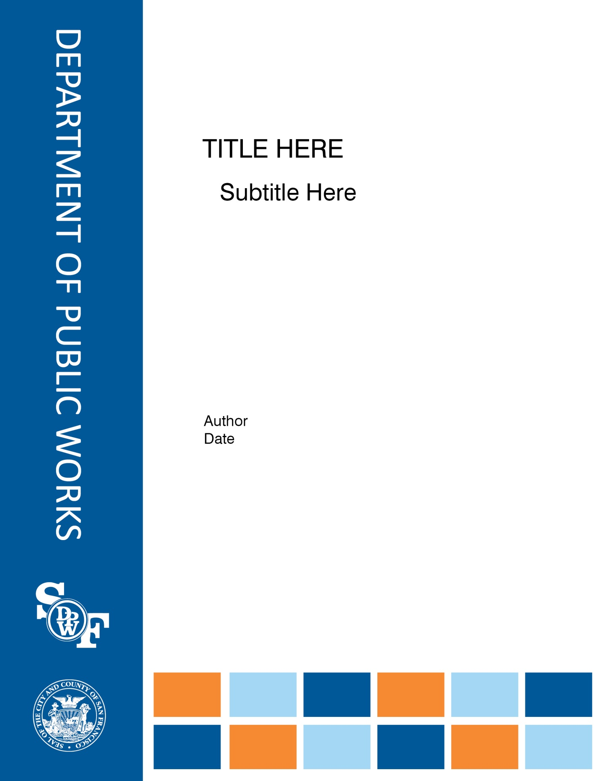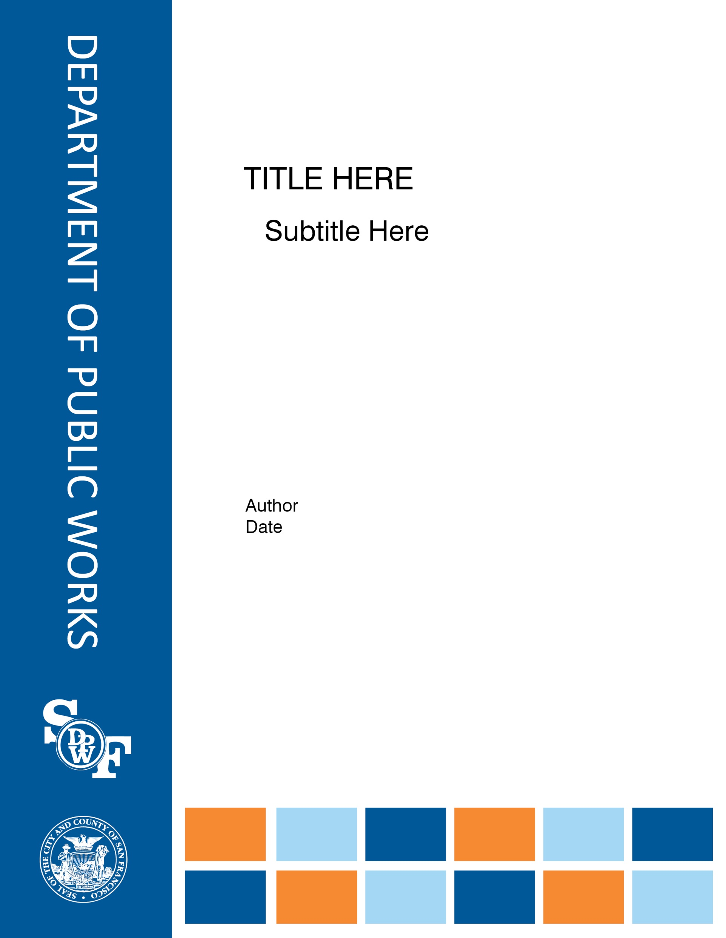

**City & County of San Francisco**

Honorable Edwin M. Lee, Mayor

**GSA – Office of the City Administrator**

Naomi Kelly, Chief Administrative Officer

**Department of Public Works**

Mohammed Nuru, Director

**Earthquake Safety and Emergency Response Bond Program #1**

Monthly Status Report

December 2012

Prepared for the

* San Francisco Police Department
* San Francisco Fire Department
* Public Utilities Commission

Submitted by Charles Higueras

Program Manager

# table of contents

Program-wide Executive Summary Page 1-4

Program Summary and Status

San Francisco Police Department

Public Safety Building Page 5-16

San Francisco Fire Department

Neighborhood Fire Stations Page 17-55

San Francisco Public Utilities Commission

Auxiliary Water Supply System (AWSS) Page 56-61

City and County of San Francisco

Office of the Controller

Bond Oversight/Accountability and Cost of Issuance Page 62-63

Funding Page 64

Attachments:

Attachment 1 – Contact Information

# Executive Summary

**Public Safety Building**

Basement wall construction continues through December and are and on-track with start of structural steel erection in mid-January 2013.

Bid and Award for a number trade packages and Building Permit reviews continue through December with a targeted start of structural steel erection in early 2013.

**Neighborhood Fire Stations**

Seismic Projects: Schematic Design phase for Station #16 is proceeding on schedule - the 100% Schematic Design set was submitted on schedule on December 28, 2012. Concept phase for Station #5 will resume in January 2013.

The Warriors development team made various public presentations of their proposed project at Piers 30/32, which includes a new Fire Boat Station #35 at the site. In January 2013 DPW will continue to evaluate next steps to retain the Pier 22-1/2 site as a viable backup option if needed.

Comprehensive Projects: The cost estimate for the 100% Design Development for Station #36 deliverable was received on December 14 and is within budget.

Focused Scope Projects: Roof construction continues on package #3 (3 stations) and package #4 (4 stations). Roof preconstruction phase at Station #2 is nearly complete, and the JOC contractor is scheduled to begin work in January 2013. Paint mockup was installed at Station #38 on schedule, and SFFD approval is pending. Package 4 building envelope package was advertised on scheduled on December 10, with bids due on January 9, 2013. Bidding of remaining exterior paint projects will follow completion of roof construction. Emergency generator Station #6 was advertised on December 7 as scheduled, targeted to Micro LBE bidders. Emergency generator Station #17 design was received by DPW as scheduled on December 5. SFFD direction is to compare the two delivery methods (design-bid-build at Station #6 and design-build using DPW in-house forces) upon completion. The existing emergency generator at Station #15 is experiencing mechanical malfunction and the SFFD directed the Station #6 team to replace as soon as feasible. Design is scheduled to be submitted on January 13, 2013.

**Auxiliary Water Supply System (AWSS)**

AECOM/AGS JV is working on the final project report for the planning study, which is due by March 2013.

The design proposal for Pumping Station 2 is being developed. A proposal to analyze alternatives to Pumping Station 2 renovation is being circulated for approval. Design work continued for Ashbury Tank, Jones Street Tank, Twin Peaks Reservoir, and Pumping Station 1. The bid and award period for the combined Ashbury Tank, Jones Street Tank, and Twin Peaks Reservoir contract is scheduled to start by March 2013.

Design work continued for new cisterns. The bid and award period for New Cisterns Contract A is scheduled to start by February 2013.

**Budget and Expenditures**

The total ESER bond funds allocation is $301,267,771 which represents 73% of the budget. The above allocation, however, should be $301,115,000 which represents an over-allocation of $152,771. This will be corrected next reporting period. The ESER expenditures increased by $1,360,938 from $64,819,084 to $66,180,022 which represents 16% of the budget. The following is summary of the budget and expenditures:



As part of the AAO FY 12-13, the Fire Department received authorization to appropriate $8,272,000 which DPW has allocated to the Fire Boat Station No. 35 and the Fire Station No. 35 Slab Repair as noted above. Together with the ESER approved bond program, the total budget is $420,572,000.

For a detailed breakdown of the budget and expenditures refer to pages 3 and 4.





# program summary and status

**Public Safety Building**

|  |  |
| --- | --- |
| H:\7410A PUBLIC SAFETY BUILDING\9.0-Construction Admin\9.11-CA_Photos\2012.12. December\2012.12.11_SC\IMG_7922.JPG  Reinforcement at North basement wall (Mission Rock St.) before concrete placement | H:\7410A PUBLIC SAFETY BUILDING\9.0-Construction Admin\9.11-CA_Photos\2012.12. December\2012.12.27_SC\IMG_7994.JPG  Subgrade waterproofing work completed at East shoring wall |
| H:\7410A PUBLIC SAFETY BUILDING\9.0-Construction Admin\9.11-CA_Photos\2012.12. December\2012.12.11_SC\IMG_7916.JPG  Removal of concrete formwork after placement, at west basement wall (3rd St.) | H:\7410A PUBLIC SAFETY BUILDING\9.0-Construction Admin\9.11-CA_Photos\2012.12. December\2012.12.27_SC\IMG_7974.JPG  Reinforcement bar installation at East shoring wall |

**Project Description:** The Public Safety Building (PSB) is meant to provide a new venue for the SFPD Headquarters – effectively the command and control administration of the City’s police department-including the relocation of Southern District Station and a new Mission Bay Fire Station. Included in the project is the reuse of Fire Station #30, which will serve as a multi-purpose facility for the Fire Department and the community. Historic resource consultants have determined that the existing fire station is eligible for the National Register of Historic Places. Consistent with the Mission Bay SEIR Addendum No. 7, Mitigation Measures, Item D.02, this facility will be retained and reused in a manner that preserves its historic integrity. The other components of the project will be designed to be respectful of the historic integrity of the existing fire station.

Both the Police Headquarters and the Southern District Police station are located at 850 Bryant also known as the Hall of Justice. This facility is over 50 years old and does not meet current seismic codes and requirements. In the event of a major earthquake, this building is not expected to be operational. The PSB will provide a new venue for these two police elements that are a part of a larger strategy to replace the Hall of Justice, established in the City’s Capital Plan as the *Justice Facilities Improvement Program* (JFIP).

**Project Background:**  The functionality of the entire police department in the event of a major catastrophe relies on the ability of the police leadership within police command center headquarters to promptly and properly coordinate public safety services in the city. The district station plays an equally critical role in providing responsive public safety to residents of San Francisco in a timely manner. This station includes those working the front line that are the first to arrive at a crime scene, maintain the peace during difficult situations, assist in the investigation of criminal activity; provide support to other first responders including the Fire Department, the Medical Examiner and Crime Scene Investigation (CSI).

**Project Status:**

Construction Activities in December:

* 30” storm drain connecting pipe was completed in November, with the testing and video re-scheduled for the week of 1/7/13.
* Construction of basement wall continued through December, including rebar, formwork, waterproofing, and concrete placement.
* Man-hoist concrete pad was constructed, in preparation for building structure construction.
* Shotcrete test panels were constructed off-site.
* Structural steel fabrication continued through December with a target steel erection to begin mid-January 2013.

Design team continues to engage with the CM/GC and Trade Partners on design-construction coordination issues, including Curtainwall glazing / screen assembly design; architectural concrete specifications; and structural steel fabrication.

The Architectural Permit Addendum was submitted to DBI, immediately following the completion of ADA/Accessibility plan check review in December. DBI continues to review, in parallel, MEP Permit Addendum and Building Permit for Fire Station 30. A remainder of three deferred Permit Submittals will be submitted to DBI by the Contractor by mid- 2013.

**Project Schedule:**

RFQ/RFP issuance, pre-qualification, and pre-bid meetings, RFQ application scoring, are occurring for various trade packages.

Trade Package Activities in December:

* Roofing/Green-roof Bid Opening (on 12/19) accepted 3 bids, with review of the apparent lowest bid by CMD and DPW currently underway.
* CMU Bid opening (on 12/21) accepted 2 bids; the lowest apparent bid is deemed non-responsive, and the second bid is over the budget for this scope.
* RFQ responses were issued and accepted in December for SFMTA Utilities Relocation DB (due 12/20); and Flooring (due 12/21), followed by evaluation of RFQs by Pankow, DPW, and Vanir.
* RFQ Evaluation for Specialty and Equipment was completed on 12/13, resulting in three qualified bidders.
* RFQs for Ceramic Tile scope was issued on 12/18, and applications will be accepted through 1/4/2013.

**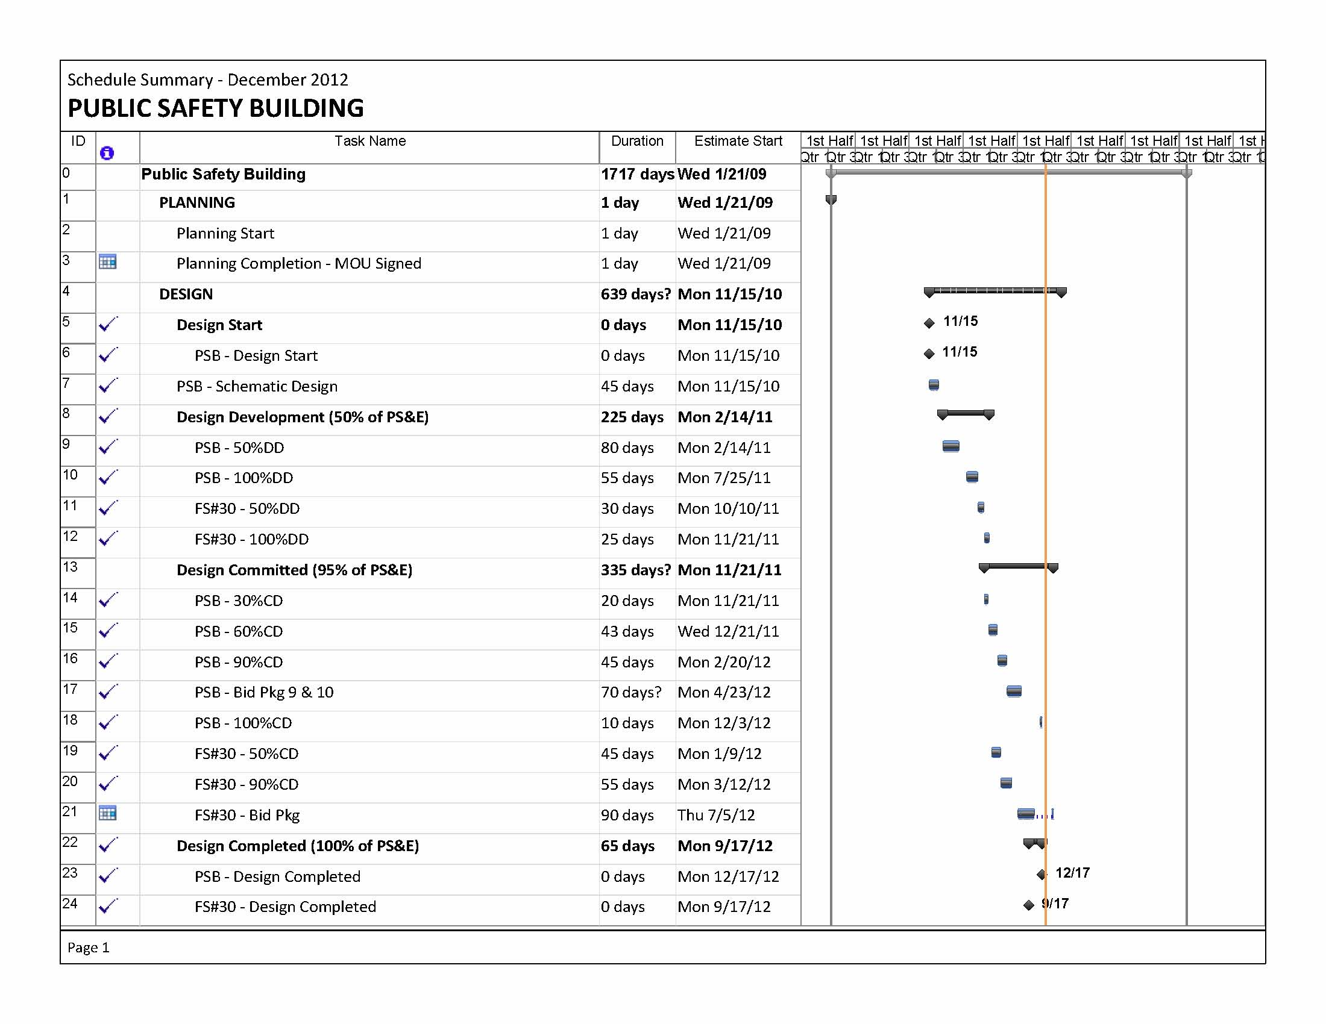**

**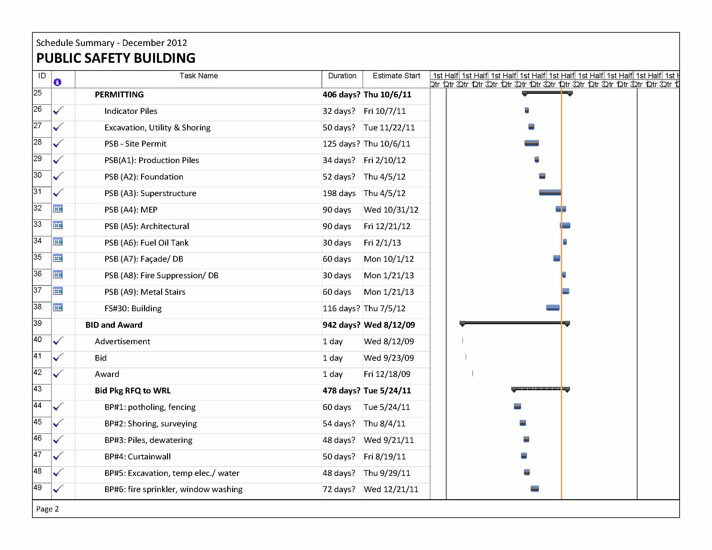**

**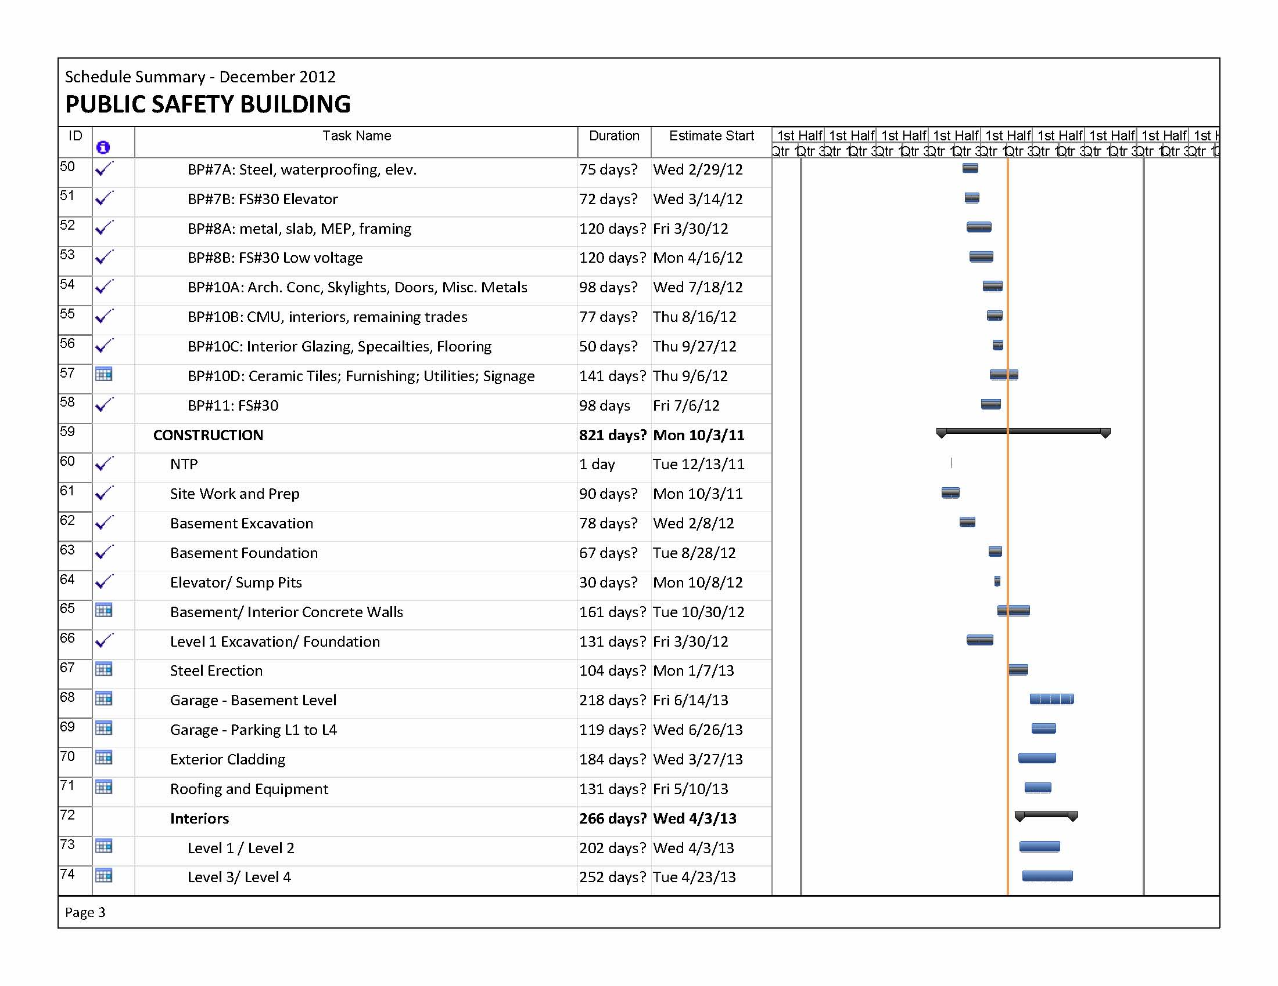**

**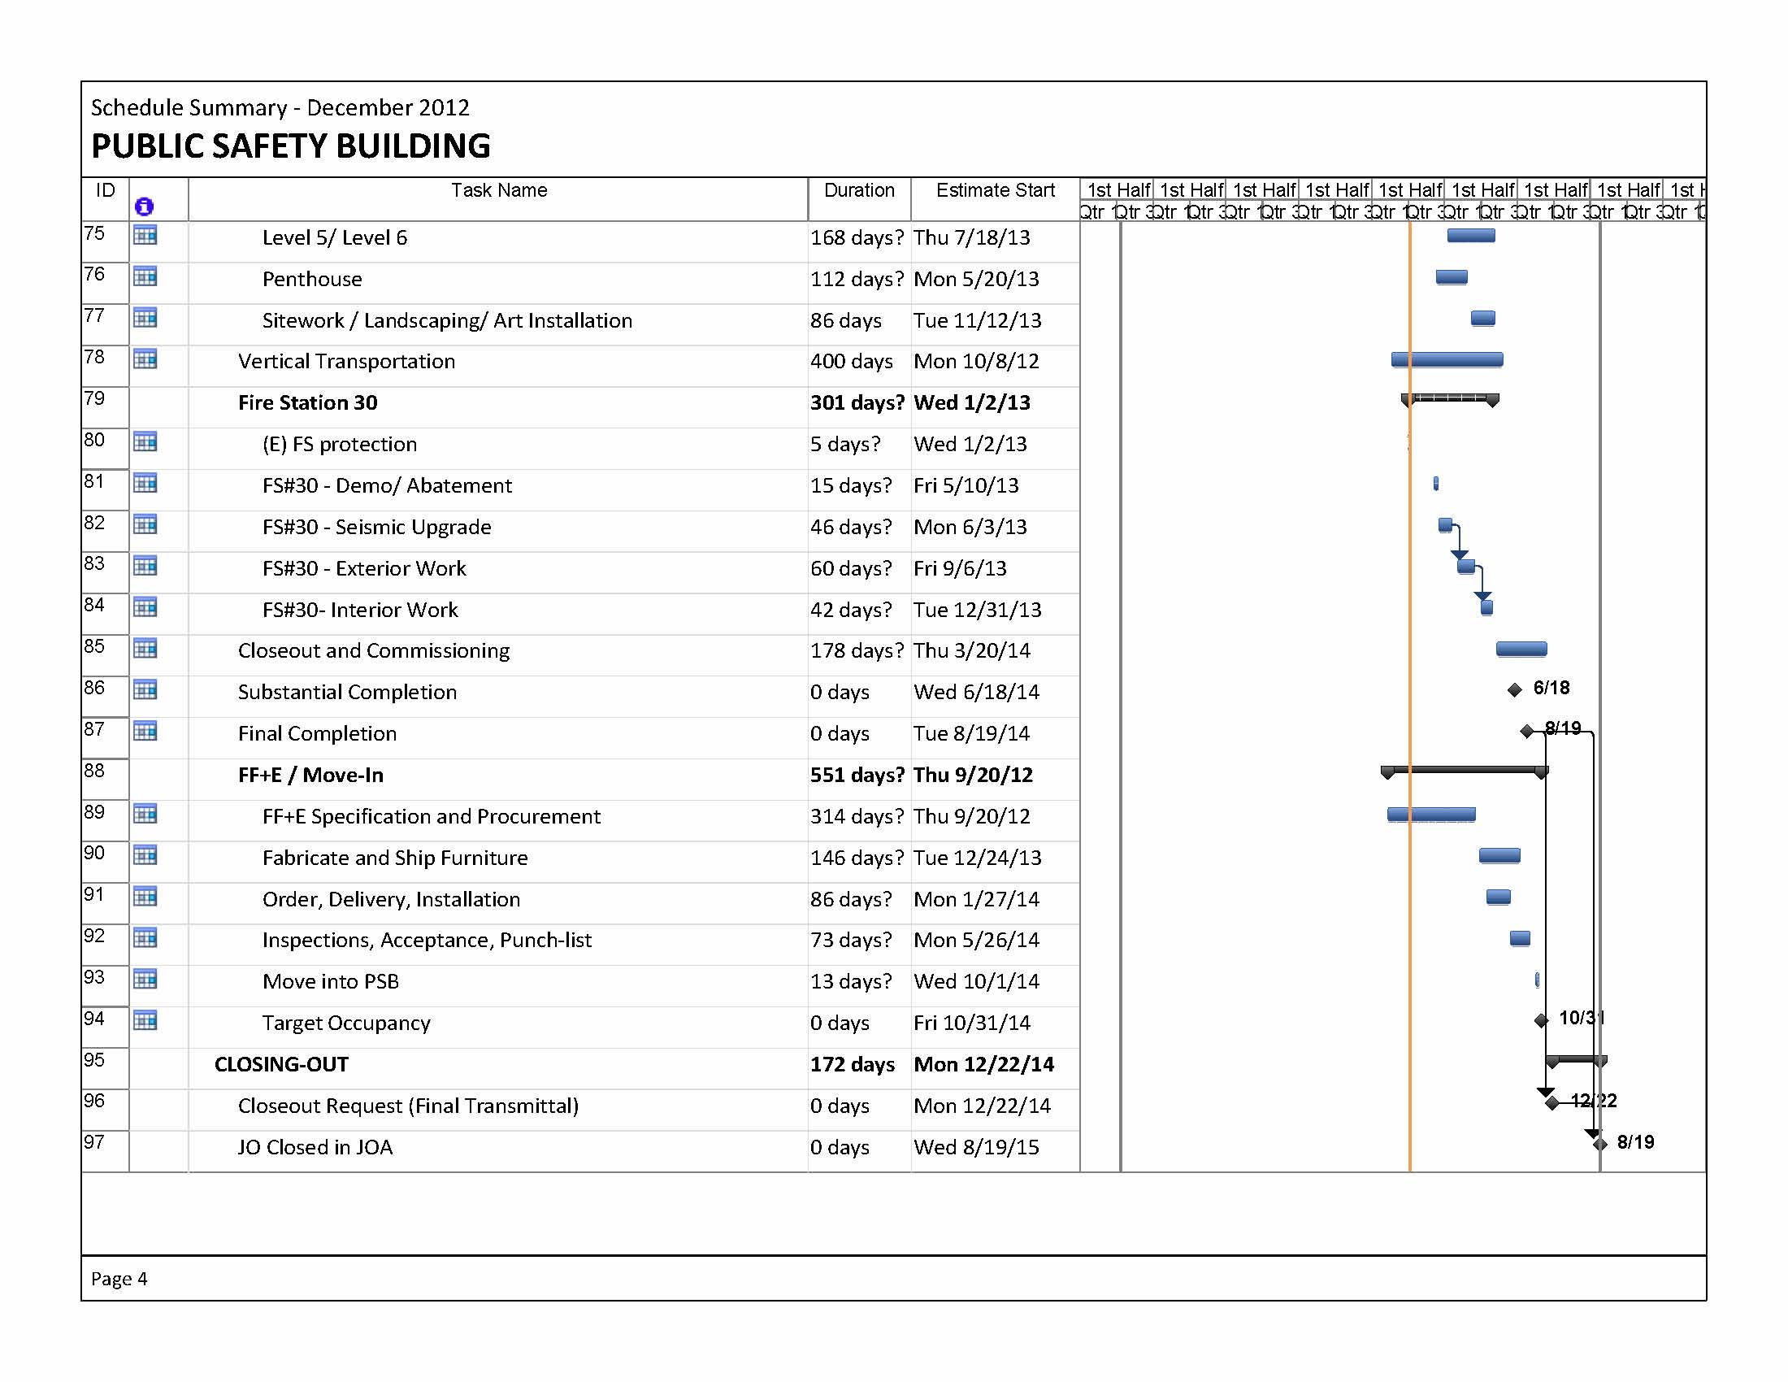**

**Project Budget Status:** The budget for the Public Safety Building is $239,000,000.The approved appropriated amount is $227,217,257 funded from the proceeds of both the First and Second Bond Sales.

**Current Expenditures:** The expenditures increased by **$394,894** from $49,985,136 to $50,380,030. The following is an account of the expenditures for this month:

1. CONSTRUCTION, PURCHASE, & INSTALLATION increased by **$19,917** as follows:

* Task 28 Art Commission increased by $19,917 for administrative services through December 21.

2. PROJECT CONTROL increased by **$374,977** as follows. Note all labor activities provided by DPW are through December 21 unless otherwise noted.

* Task 11a DPW/PM increased by $61,336 for project management services.
* Task 18 DPW/Administration increased by $3,012 for Public Relations provided by DPW.
* Task 84 Department of Building Inspection increased by $361 for DBI Permit Addendum #3.
* Tasks 11f and 12c DPW Disability Access Coordination fees increased by $2,989.
* Task 20 DPH Fees – Soil Investigation fees increased by $1,241.
* Task 11b DPW BDC increased by $88,194 for architectural services including submittal of BP 19 and Permit Addendum 5.
* Task 12a DPW IDC Structural increased by $765 for peer review.
* Task 11c DPW BDC increased by $30,337 for FF&E design development services.
* Task 5D Vanir increased by $94,136 for Construction Management Support Services provided in September and October.
* Task 11d DPW BDC increased by $48,384 for construction management.
* Task 31 PUC/EnerNoc increased by $5,646 for building commission services.
* Task 5G ENGEO Inc. increased by $28,556 for special inspection services provided in August.
* Task 13d DPW IDC increased by $1,557 for materials testing services.
* Task 13c Site Assessment and Remediation increased by $3,085 for administration of contract service orders.
* Task 53 GTC Geotechnical increased by $5,378 for geotechnical services provided in October and November.

**Current Allocations:** The current allocation remained at $227,217,257.The job order reserve (Task 99) decreased by $1,603 from $15,249,054 to $15,247,451 to fund following transactions:

* Task 84 Department of Building Inspection increased by $362 for DBI Permit Addendum #3.
* Task 20 DPH Fees – Soil Investigation increased by $1,241.

Refer to pages 13 thru 16 for further detail.









**Neighborhood Fire Stations**

|  |  |  |
| --- | --- | --- |
| **Fire Station #15 Roofing** |  |  |
| **FS 15.JPG** | | |
| **Fire Station #18 Roofing** | | |
| **FS 18_2.JPG** |  | **FS 18_5.JPG** |
| **Fire Station #26 Roofing** | | |
| **FS 26.JPG** | | |

**Project Description:** The ESER 1 bond will renovate or replace selected fire stations to provide improved safety and a healthy work environment for the firefighters. The selected stations are determined according to their importance for achieving the most effective delivery of fire suppression and emergency medical services possible.

**Project Background:** Many of the 42 San Francisco Fire Stations have structural, seismic, and other deficiencies. Some may not be operational after a large earthquake or disaster; threatening the ability of the firefighters to respond to an emergency. In addition, there are other fire department resources that support and augment the capacity of the department to provide effective fire suppression capability.

Prior to approval of the bond program, the majority of the City’s fire stations and support facilities were assessed for their respective condition and to identify vulnerabilities or deficiencies that could compromise their essential role as deployment venues for first responders.

For planning purposes, the assessment reports were reviewed by cost estimators who prepared estimates of the cost of correcting the conditions noted in the assessments. The cost estimates indicate only the overall “order of magnitude” of the various facility deficiencies and relative proportions of various types of work.

Preliminary assessment of the neighborhood fire stations indicate that the sum of all existing deficiencies would require a budget exceeding $350 million to correct, significantly more funds than are available for such purposes in this bond. Therefore, additional detailed planning is required to focus the expenditures of this bond towards the most beneficial and cost effective immediate rehabilitation and/or improvement projects.

A preliminary list of projects to be completed by the ESER 1 bond was identified by DPW and the Fire Administration, and accepted by the Fire Commission at their meeting of September 23, 2010.

The ESER 1 bond program identified improvements to 16 of the 42 neighborhood fire stations, as well as the Fire Boat Station and the Equipment Logistics Center, which will consolidate the Bureau of Equipment (currently at 2501 25th Street) with the Emergency Medical Services and Arson Task Force at 1415 Evans.

Typically, DPW architectural and engineering staff will provide the services for all projects unless otherwise noted.

**Project Status:**

SFFD evaluated project scope and program budget options prepared by DPW and approved on February 29, 2012 a final slate of Groups I, II and III projects to be completed as part of ESER I. Direction was also provided for the preferred development of the Fire Boat Station and analysis of the Emergency Logistics Center (ELC.) The approved slate of projects was presented to the SF Fire Commission on April 26, 2012. Progress on the slate of projects was presented to the Fire Commission on October 25, 2012.

Seismic Projects: Stations #16 and #5

Design services are being provided by DPW BDC/IDC. Conceptual design began on Fire Stations #5 and #16 replacement projects on April 16, 2012. SFFD review proceeded as scheduled on June 1 (Station #16) and June 6 (Station #5). SFFD requested alternate options at Station #16 and at Station #5. DPW BDC/IDC completed these alternates as requested.

Station #16:

Conceptual design of Fire Station #16 prepared by DPW BDC/IDC was approved by the Fire Chief on September 10, 2012. Schematic Design phase proceeded on schedule October 9, 2012. The geotechnical report prepared by DPW IDC was received on October 25, 2012. The 50% SD submittal was received as scheduled on November 15, 2012 and the 100% SD submittal was received as scheduled on December 28, 2012. The cost estimate is underway and will be completed in January 2013. Approval for Civic Design Review Phase I was sought at the November 19, 2012 meeting, but was not received. Committee members requested that the design team explore a contemporary design option. The revised design presentation is scheduled for January 14, 2012.

Station #5:

SFFD requested alternate design elements for Conceptual design of Fire Station #5 to accommodate a second truck if necessary. Concepts were presented to the Fire Chief on September 10, 2012. The SFFD approved the two story, two truck development option on November 15, 2012. The Project Review Application was submitted to City Planning as scheduled on December 6, 2012. Design team will be mobilized to complete the concept phase in January 2013, focusing on completing the proposed floor plans and drafting the elevations.

Fire Boat Station 35:

Design services are being provided by DPW BDC/IDC.

The Fire Boat Station #35 slab replacement project completed as scheduled on June 20, 2012 in good time for the return of the fire engine to Station #35 as scheduled on July 1, 2012 per SFFD agreement with the Firefighter’s Union. The Fire Boat Station slab replacement project punch list work began in mid July as scheduled. The contractor is DPW’s JOC contractor, AzulWorks. In order to close this project permit, the Port is requiring modifications to the existing gas line installed under a previous project permit which remains open. Our slab replacement project anticipated completing this work in December but could not due to the rain. This work is scheduled to be completed in January 2013.

A community Open House was held as scheduled on October 3, 2012 for the new project at the existing location. The Project Review Application for the Fire Boat Station #35 replacement projects was submitted to City Planning as scheduled on June 15, 2012. City Planning’s response to the Project Review Application for Station #35 was received as scheduled on October 24, 2012. Of the three options included in the application, Planning preferred Option 1-A, and provided comments for implementation in the following design phase.

The Warriors presented their proposed development project at Piers 30/32 to the Port Commission on November 13, 2012. The Warriors’ development team has asked that the City and SFFD consider relocating the Fire Boat Station to Piers 30/32, and the request has been accepted tentatively pending the resolution of all relevant matters, including the inclusion of Pier 22 1/2 (existing location) in the 30/32 master EIR, as an alternative, and expectations for design and funding. In January 2013 DPW will continue to evaluate next steps to retain the Pier 22-1/2 site as a viable backup option if needed.

Equipment Logistics Center (ELC):

The ELC project was identified after the passage of the bond – it was suggested as a project combining the Bureau of Equipment and Emergency Medical Services. In this configuration, the sum total of functional program area makes it infeasible for it to occur at 1415 Evans; more significantly, the budget for such a project is not available within the NFS funding.

In lieu of this project, the SFFD requested that a smaller facility, dedicated to the storage of essential material, be considered at the lot behind Station 9. The conceptual program and cost estimate was completed in February 2012, and is pending a decision as to whether to dedicate bond funds to accomplish this project.

Comprehensive Project: Station #36

Design services are being provided by DPW-BDC’s as-needed consultant, Paulett Taggart Architects. Schematic Design phase on Fire Station #36 comprehensive renovation was completed on schedule on July 16, 2012. SFFD reviewed and accepted the documents, providing minor comments. Cost estimation has been completed and the project is currently within budget. The 50% Design Development deliverable for Fire Station #36 comprehensive renovation was received on September 28, 2012. Project was presented to Civic Design Review Committee for combined Phase I/II approval on September 17, 2012 as scheduled. The Committee lost quorum before our presentation; the item was heard and no major comments were received from the 2 out of 3 members who heard the presentation. Approval was received as scheduled for the October 15, 2012 meeting. 100% Design Development deliverable was received as scheduled on November 30, 2012, with cost estimate received as scheduled on December 14, 2012. The project remains within budget. Design is proceeding on track to meet LEED Gold for Commercial Interiors standards as approved by the Green Building Coordinator, San Francisco Deptartment of the Environment.

Focused Scope Projects:

Design and construction work on Groups I and II Focused Scope stations continues.

Roof Replacements:

Roof replacement construction phase at Station #28 began on August 7, 2012 and successfully achieved substantial completion on September 28, 2012 as scheduled. Roof designs for roof packages 2R, 3, and 4 (total of 10 stations) were amended to APP-type material (not SBS) system. Consulting CM performed constructability review in early July, and bids were received in August as scheduled. The contractor for package #3 at Stations #18, #31 and #40 is Western Roofing and the contractor for package #4 at Stations #15, #17, #26 and #32 is Pioneer Roofing. Both companies are located in San Francisco. NTP for roof package 3 was issued on October 11 and the Preconstruction phase was completed in November 2012. Site work began as scheduled in December 2012. NTP for roof package 4 was issued on October 9 and the Preconstruction phase was completed in November 2012. Site work began as scheduled in December 2012. Package 2R bids received were over the budget by $118K. One of the three stations included in package 2 is Station #2, and the condition of this station’s roof warrants immediate attention. Accordingly, Station #2 roof was removed from Package 2R and pricing was received through the JOC process in October 2012. NTP was issued on November 29, 2012. The Preconstruction phase is nearly complete, and construction is scheduled to begin in January 2013. The final roof package, 2R2 for the remaining 2 stations #10 and #13 is scheduled to be advertised in January 2013.

Exterior Envelope:

Building exterior envelope packages for 15 Fire Stations will be bid in 6 packages. Packages 1 (Fire Station #38) and 2 (Fire Station #42) each for one fire station were bid to Micro LBE contractors as set-aside contracts. Despite diligent outreach to Micro LBE contractors, only 1 bid was received on September 26, 2012 and it far exceeded the budget. SFFD has approved DPW BBR pricing of the work at these two stations for in-house execution. SFFD has approved Package 3 for two fire stations (Stations #28 and #41) pricing by DPW - BBR for in-house execution. In addition, at SFFD direction Station #49 exterior paint was added to the project list, and approved DPW-BBR pricing of this work for in-house execution as well. The roofs at these 4 stations were previously completed and paint work can commence immediately upon award. NTP was issued as scheduled on November 21, 2012 for Station #38. The preconstruction phase is underway. Work is scheduled to begin at Station #38 in January 2013. Packages 4, 5, and 6 for 3 stations, 3 stations, and 4 stations respectively will be bid to B license contractors. The paint bid packages will follow completion of the roof bid packages. Package 4 (Stations #15, 32 and 40) was advertised in early December as scheduled with bids due on January 9, 2013.

Shower Reconstruction:

Shower reconstruction package 1 for Stations 15, 6, and 38 is underway. Construction began as scheduled at Station 15 on April 18, 2012. Contractor changed certain installation details without prior approval, and corrective work will necessitate additional fabricated materials. In mid September 2012 as scheduled, the manufacturer arrived at the site from out of state to resolve final details with the architect of record and the Fire Department. Material order for these corrective details is nearly complete. Initial pricing was received by the contractor which has been revised, and the Change Order is in process prior to the work proceeding. Material has a 6 week lead time, therefore work is anticipated to proceed in the field at the end of February 2013. Station 15 must be successfully completed prior to commencing work at Station 6 and subsequently Station 38, both to be executed by DPW BBR.

Emergency Generator Replacement:

Emergency generator implementation strategy was completed in September 2012 and design is moving forward with DPW’s as-needed electrical engineer at Station 6 as a prototype for design-bid-build project delivery. The 100% design was received as scheduled on November 26, 2012 and the project was bid as scheduled on December 7, 2012. IDC began design work on November 2, 2012 at Station 17 as a DPW in-house IDC design-BBR build prototype. The 50% design set was submitted as scheduled on December 5, 2012. SFFD direction is to compare the two delivery methods upon completion. The existing emergency generator at Station #15 is experiencing mechanical malfunctions and the SFFD directed the Station #6 team to replace as soon as feasible. Design is scheduled to be submitted on January 13, 2013.

**Project Schedule:** SFFD evaluated project scope and program budget options prepared by DPW. On February 29, 2012, SFFD approved a final slate of Groups I, II and III projects to be completed as part of ESER 1. Next step will be development of the baseline project schedule, which will be published in subsequent reports. For a copy of the Project Schedule, refer to following page.

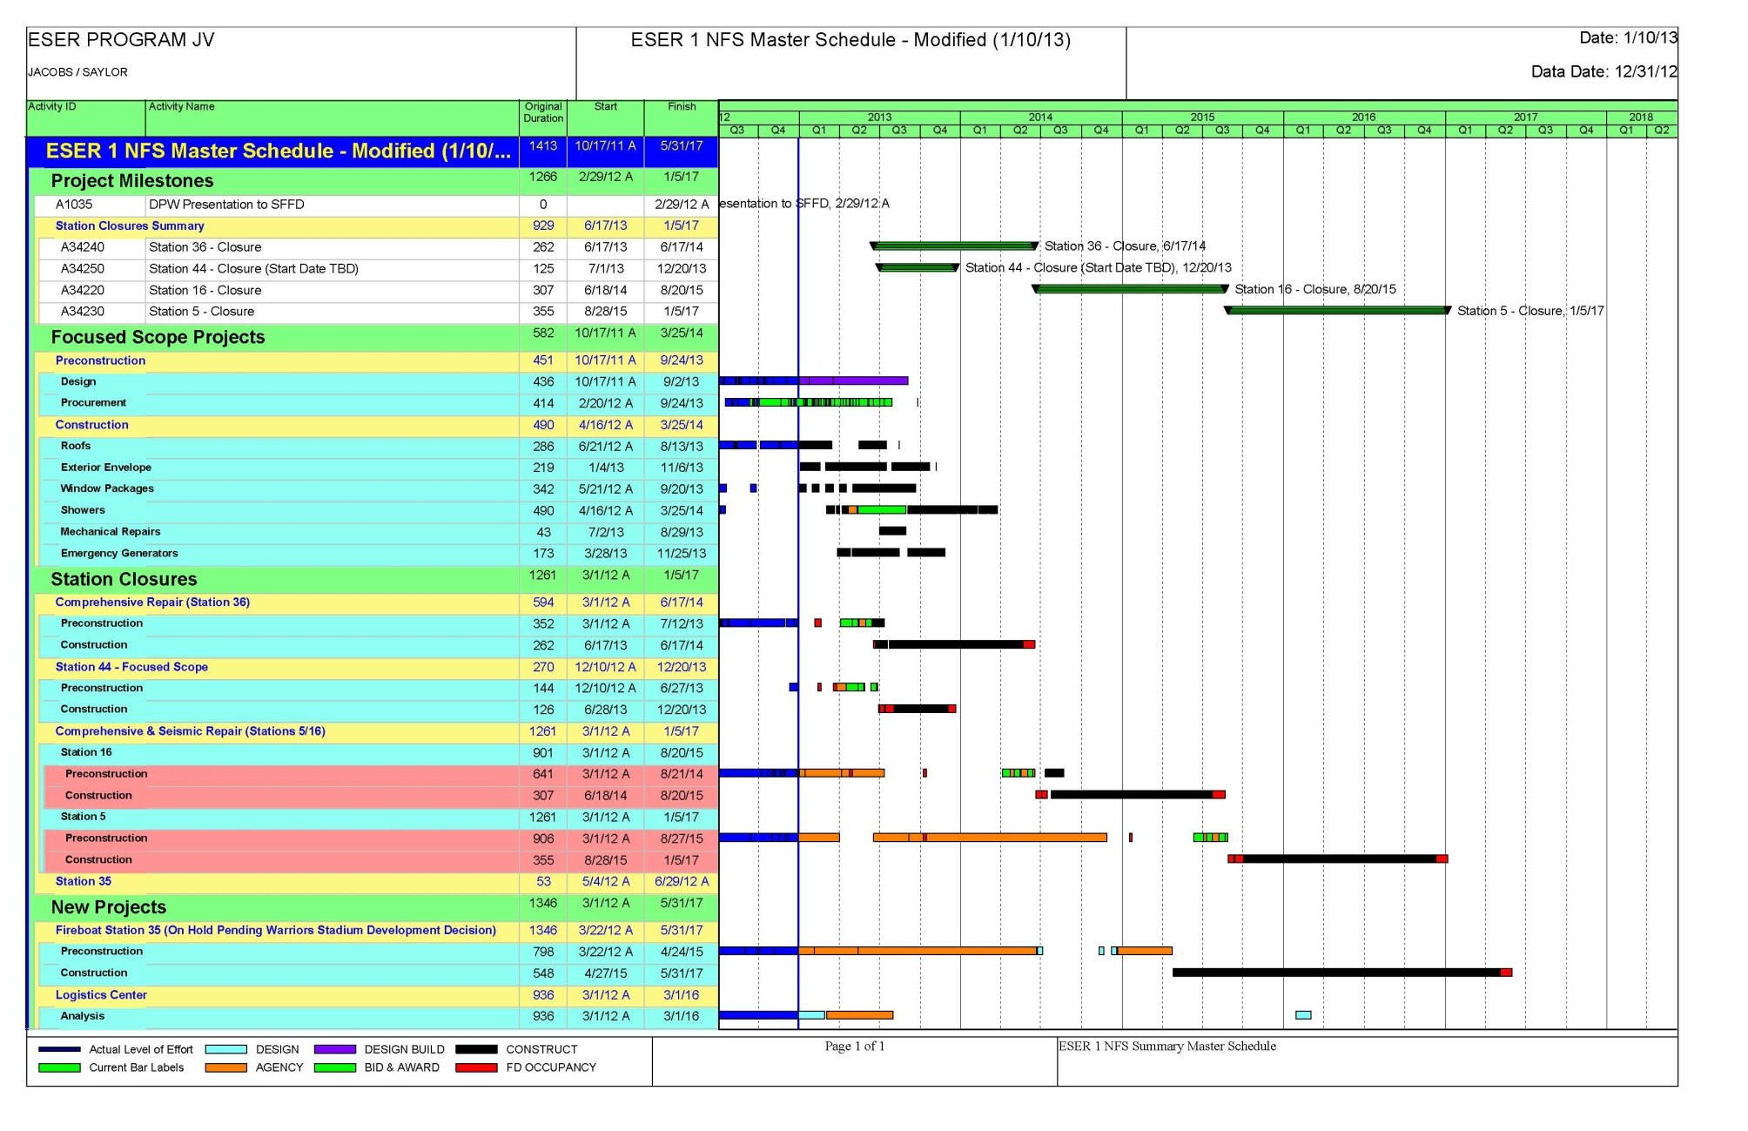

**Project Budget Status:** The budget for the Neighborhood Fire Stations is $64,000,000. Not included in the $64,000,000 is $1,100,000 for bond oversight, accountability and bond cost of issuance. Together, the budget is $65,100,000 as reported in the Bond Program Report. The approved appropriated amount is $24,701,310 funded from the proceeds of the First and Second Bond Sales. As discussed in the Project Status, an additional $8.272 million will supplement the ESER1 budget for the New Pier Fire Boat Headquarters and additional work not included as part of ESER1 scope or budget. Together, the total Program budget is $73,372,000. Included in the $73,372,000 is $1,100,000 for the GOB oversight, accountability, cost of issuance and associated costs. These costs are reported separately and therefore the budget is reduced to $72,272,000.

**Current Expenditures:** The expenditures funded by the ESER Bond Funds increased by $474,164 from $6,232,434 to $6,706,597. The expenditures funded by Fire Facility Bond Funds increased by $2,454. Combined, the total expenditures of $476,618 were incurred under separate job orders as follows:



A detailed breakdown of the expenditures for each project is available on the pages noted above.

**Job Order 7431A Roofing** (CESERFS31)

**Current Expenditures:** The expenditures increased by $99,775 from $1,527,808 to $1,627,583 as detailed below. Labor expenditures are through 12/21/12.

* $82,375 by the Department of Public Works
  + $59,477 for Building Design and Construction architectural design services. Total expenditures are $446,586 which represents 85% of the allocated budget of $527,855.
  + $711 Infrastructure Design & Construction (IDC) for mechanical design services. Total expenditures are $2,241 which represents 20% of the allocated budget of $11,458.
  + $22,187 Project Controls & Systems. Total expenditures are $32,544 which represents 48% of the allocated budget of $67,888.
* $16,471 by Rodan FS#42. Total expenditures are $123,862 which represents 100% of the allocated budget.
* $504 by DBI for FS#2 roof permit fees.
* $425 by OLSE.

**Current Allocations:**  The allocation remained at $4,280,460. The job order reserve remained at $200,619.



**Job Order 7432A ESER Fire Stations-Group 1 and 2 Showers** (CESERFS32)

**Current Expenditures:** The expenditures increased by $1,635 from $174,053 to $175,688 as detailed below. Labor expenditures are through 12/21/12.

* $1,635 for BDC architectural services. Total expenditures are $97,079 which represents 63% of the allocated budget of $153,221.

**Current Allocations:** The allocation remains at $1,087,816. The job order reserve remained at $802,805.



**Job Order 7434A NFS Focused Scope Window Repairs** (CESERFS34)

**Current Expenditures:** The expenditures increased by $560 from $63,591 to $64,151 for the following service:

* $560 for BBR.

**Current Allocations:** The allocation remained at $1,000,779. The reserve remained at $689,867.



**Job Order 7435A NFS Focused Scope Mechanical Repairs** (CESERFS35)

**Current Expenditures:** No expenditures have posted under this job order.

**Current Allocations:** The allocation remains the same at $1,711,166. No transactions were funded in this month.



**Job Order 7436A NFS Focused Scope Exterior Envelope** (CESERFS36)

**Current Expenditures:** The expenditures increased by $3,263 from $92,117 to $95,380 as detailed below. Labor expenditures are through 12/21/12.

* Department of Public Works, BDC incurred $3,263 for design services. Total expenditures are $95,380 which represents 82% of the allocated budget of $116,000.

**Current Allocations:** The allocation remained at $1,583,791. Task 41 Package #2 and Task 43 Package #3, previously budgeted for $94,695 and $146,976 respectively, were reduced to $0. These funds were allocated as follows:

* Task 15 BBR labor – budget was created for $52,000 related to service order 412854 FS#38.
* Task 75 BBR – materials – budget was created for $11,000 related to service order 412854 FS#38.
* Task 40 FS#1 and FS#15 increased by $95,547 from $114,615 to $210,162.
* Task 99 job order reserve increased by $83,124 from $1,111,505 to $1,194,629.



**Job Order 7437A NFS Focused Scope Generators** (CESERFS37)

**Current Expenditures:** The expenditures increased by $11,535 from $25,700 to $37,235 as detailed below. Labor expenditures are through 12/21/12.

* $11,535 DPW/IDC for electrical design services. Total expenditures $17,010 represents 46% of the allocated budget of $37,176.

**Current Allocations:** The allocation remained at $1,544,978. The job order reserve decreased by $232,650 from $1,462,732 to $1,230,082 to fund the following transactions:

* Task 13 increased by $2,850 from $3,100 to $5,950 for Administration fees related to GHD Inc. CSO modification.
* Task 40 a budget was created for $201,300 related to FS#6 construction costs.
* Task 50 GHD Inc. increased by $28,500 from $31,970 to $60,470 for engineering consulting services related to FS#15 Emergency Generator Replacement.



**Job Order 7439A NFS Focused Scope Miscellaneous Services** (CESERFS39)

**Current Expenditures:** The expenditures increased by $46,603 from $68,522 to $115,125 as follows:

* $1,134 DPW/PCS for CSO Administration Services.
* $45,469 Millennium for hazardous materials ACM survey of 15 fire stations.

**Current Allocations:** The allocation remained at $1,175,993. The job order reserve remained at $1,051,569.



**Job Order 7427A Fire Station 36** (CESER1FS27)

**Current Expenditures:** The expenditures increased by $48,901 from $224,389 to $273,290 as detailed below. The labor costs are through 12/21/12.

* $15,733 by the Department of Public Works for the following services:
  + $9,544 BDC for architectural services.
  + $6,189 for IDC Engineering as follows:
    - $1,035 for regulatory affairs services. Total expenditures are $1,035 which represents 14% of the allocated budget of $7,614.
    - $6,188 for structural design services. Total expenditures are $28,670.64 which represents 60% of the allocated budget of $47,900.
* $33,168 for Paulett Taggart Architects for schematic LEED administration, HVAC plumbing, Waterproofing, electrical and architectural services. Total expenditures total $181,380 which represents 32% of the allocated budget of $564,294.

**Current Allocations:** The allocation remained at $1,000,000. The project reserve remained at $315,146.



**Job Order 7440A New Fire Station 5** (CESER1FS40)

**Current Expenditures:** The expenditures increased by $29,274 from $149,887 to $179,161 as detailed below. The labor expenditures are thru 12/21/12.

* Task 11 BDC expenditures increased by $2,248 from $78,983 to $81,231 which represents 141% of the allocated budget. BDC is preparing a proposal to capture the actual level of effort provided on this project.
* Task 12 IDC expenditures increased by $4,035 from $18,614 to $22,649 which represents 49% of the allocated budget.

Services included regulatory affairs coordination services, structural, mechanical and geotechnical design services.

* Task 29 City Planning new expenditures posted in the amount of $4,620 for preliminary project assessment fees.
* Task 50 ARUP expenditures increased by $17,659 from $29,398 to $47,057 which represents 78% of the allocated budget of $60,282. Services included geotechnical and environmental provided in November.

**Current Allocations:** The allocation remains the same at $1,500,000. Task 12 was reduced by $15,044 and was reallocated as follows:

* Task 29 City Planning – budget was created in the amount of $4,620 for preliminary project assessment fees.
* Task 99 project reserve – budget increased by $10,424 from $1,297,190 to $1,307,614.



**Job Order 7441A Fire Station 9 Utility Isolation** (CESER1FS41)

**Current Expenditures:** No expenditures have posted in this job order.

**Current Allocations:** The allocation and job order reserve remain at $200,000.



**Job Order 7442A New Fire Station 16** (CESER1FS42)

**Current Expenditures:** The expenditures increased by $100,748 from $222,615 to $323,363 as detailed below. The labor expenditures are through 12/21/12.

* $98,432 for Department of Public Works for the following services:
  + Task 11 BDC Architecture the expenditures increased by $41,591 from $104,797 to $146,388 which represents 122% of the allocated budget. BDC is preparing a proposal to capture the actual level of effort provided on this project.
  + Task 12 IDC expenditures increased by $55,686 to $100,640 for design services by the following disciplines:
    - Electrical for $13,556.
    - Mechanical for $14,036.
    - Structural for $16,593.
    - Geotechnical for $9,667.
    - Regulatory Affairs Coordination for $1,834
  + Task 13 PCS expenditures increased by $891 for contract service order administration fees.
* Task 28 Art Commission increased by $2,316 from $2,316 to $4,632 for civic design review fees.

**Current Allocations**: The allocation remained the same at $1,500,000. The job order reserve remained at $1,134,868.



**Job Order 7424A Fire Boat/Fire Station No. 35** (CESER1FS24)

**Expenditures:** The expenditures remained at $81,028.

**Current Allocations:** The allocation remained at $590,288. The job order reserve remained at $510,769.



**Job Order 7425A Medical/Equipment Logistics Center** (CESER1FS25)

**Current Expenditures:** This is a new job order and no activities have been identified.

**Current Allocations:** The allocation and job order reserve remained at $100,000.



**Job Order 7433A Boat House Slab Repair** (CESERFS33 and CFCBLDFD33 )

**Current Expenditures:** The expenditures increased by $2,454 from $261,103 to $263,557 as detailed below.

* Task 13 PCS increased by $2,454 for materials testing laboratory services.

**Current Allocations:** The allocation remained at $343,000. The reserve remained at $81,894.



**Job Order 7420A Pre-Bond** (CESERFS20)

**Current Expenditures:** The pre-bond expenditures are $1,015,669. This job order is closed and no further activity is expected. It is included in this report for reference.

**Current Allocations:** The allocation is $1,015,669.



**Job Order 7430A Programming & Development** (CESER1FS30)

**Current Expenditures:** The expenditures increased by $131,870 from $2,548,942 to $2,680,811 as detailed below. Labor expenditures are through 12/21/12.

* $99,636 for Department of Public Works services:
  + Task 11 BDC increased by $88,083 for project management services.
  + Task 12 IDC increased by $710 for disability access coordination services.
  + Task 13 PCS increased by $10,843 for the contract preparation services.
* Task 51 Paulett Taggert increased by $3,261 for HRE for FS#5 and #36.
* $28,973 for Jacobs/Saylor for construction management support services provided in November.

**Current Allocations:** The allocations remained at $6,493,583. The project reserve remained at $2,937,412.



**Public Utilities Commission  
Auxiliary Water Supply System (AWSS)**

**Program Description:** The AWSS delivers high-pressure water and cistern water storage for fire suppression in several areas of the City. This program is intended to repair, replace, and extend system components to increase the likelihood of providing fire-fighting water following a major earthquake and during multiple-alarm fires from other causes.

**Program Status:**

**AWSS Planning Support Services –** AECOM/AGS JV is working on the fire insurance technical memorandum and the final project report, which is expected by March 2013. AECOM/AGS JV has submitted a proposal to examine alternatives to renovating existing Pumping Station 2, which is being circulated for approval.

**Physical Plant –** A proposal from SFPUC’s Engineering Management Bureau is being prepared for design of improvements for Pumping Station 2, with design work expected to begin in January 2013. The AECOM/AGS JV Pumping Station 2 alternatives analysis is expected to be available early in the design effort.

Design work continued for the combined Ashbury Tank, Jones Street Tank, and Twin Peaks Reservoir contract, the bid and award period for which is scheduled to start by March 2013. Staff is evaluating replacement of existing Twin Peaks Reservoir pilasters (columns that adjoin the fence scheduled for replacement) to address the absence of steel reinforcement in the pilasters and limited steel reinforcement in the curb between the pilasters.

Design work continued for Pumping Station 1, with design completion expected by May 2013.**Cisterns –** Design work continued for 16 new cistern sites. Site surveying began for the remaining 22 candidate locations, which are to be included in Contracts D, E, F, and G as funding allows. The current contracting arrangements are shown in the following table. Contract A is scheduled to start the bid and award phase by February 2013. Revised estimates of the actual number of cisterns to be built with 2010 ESER bond funds will be made after bids for Contract A are received.

|  |  |  |
| --- | --- | --- |
| **Contract** | **#** | **Location** |
| New Cisterns A |  |  |
|  | 1. | 35th Ave, Irving St |
|  | 2. | 36th Ave, Wawona St |
|  | 3. | 37th Ave, Lawton St |
|  | 4. | 37th Ave, Ortega St |
|  | 5. | 37th Ave, Rivera St |
|  | 6. | 37th Ave, Ulloa St |
| New Cisterns B |  |  |
|  | 1. | Cashmere St, Hudson Ave |
|  | 2. | Geneva Ave, Moscow St |
|  | 3. | Geneva Ave, Paris St |
|  | 4. | Holyoke St, Silliman St |
|  | 5. | Silver Ave, Colby St |
| New Cisterns C |  |  |
|  | 1. | 18th Ave, Ulloa St |
|  | 2. | 21st Ave, Ocean Ave |
|  | 3. | Funston Ave, Geary Blvd |
|  | 4. | San Buenaventura Way, St. Francis Blvd |
|  | 5. | Yerba Buena Ave, Saint Elmo Way |

**Project Schedule:** Refer to pages 58 thru 60 for schedule details.

**Project Budget Status:** Expenditures increased by $486,162 from $7,485,849 to $7,972,011.

Refer to page 61 for budget and expenditure details.

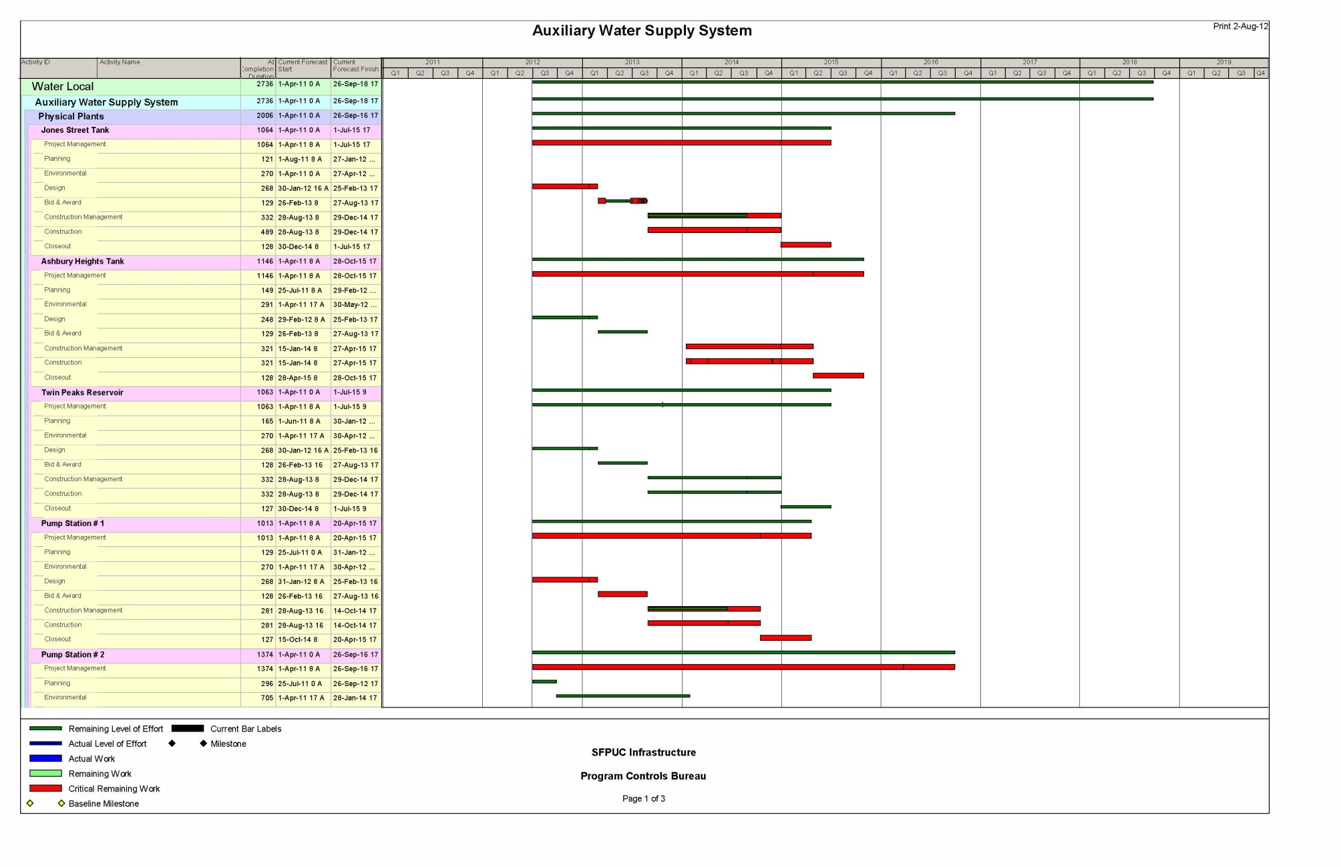

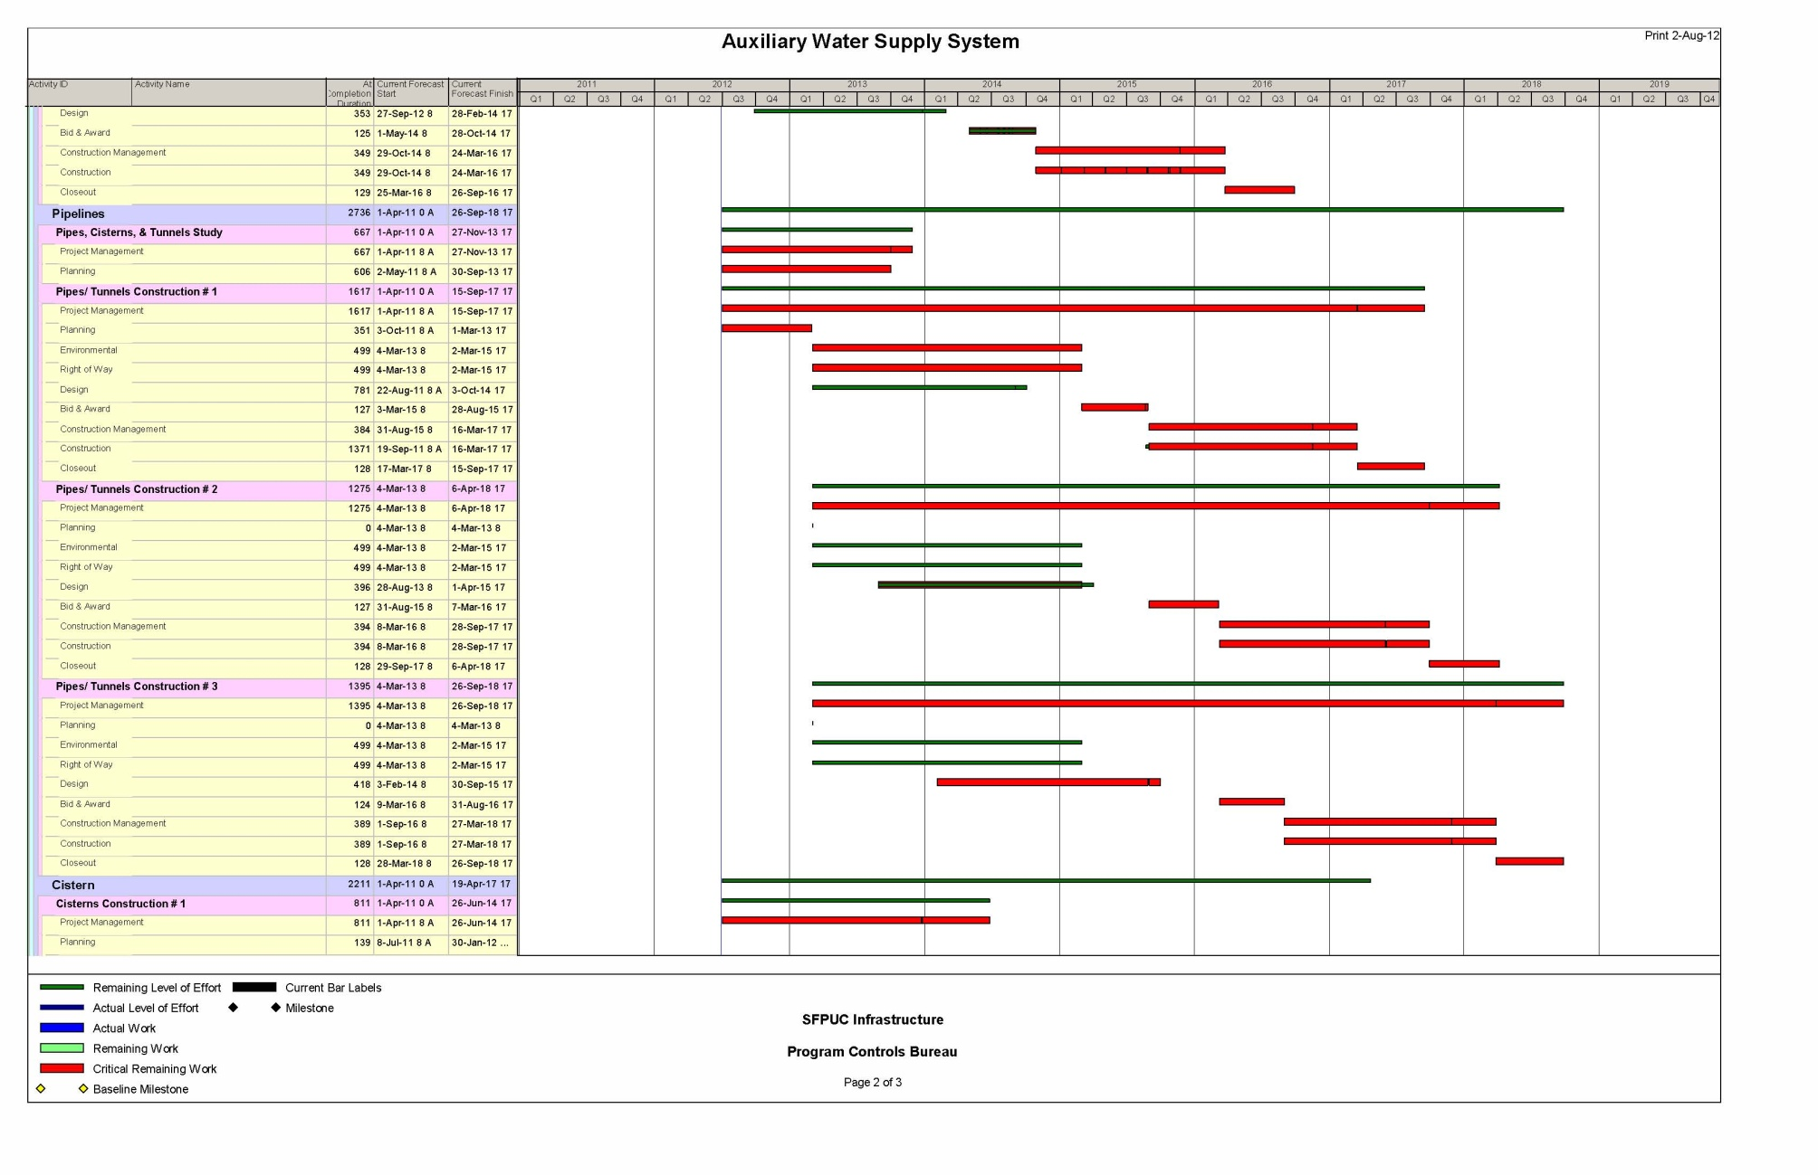

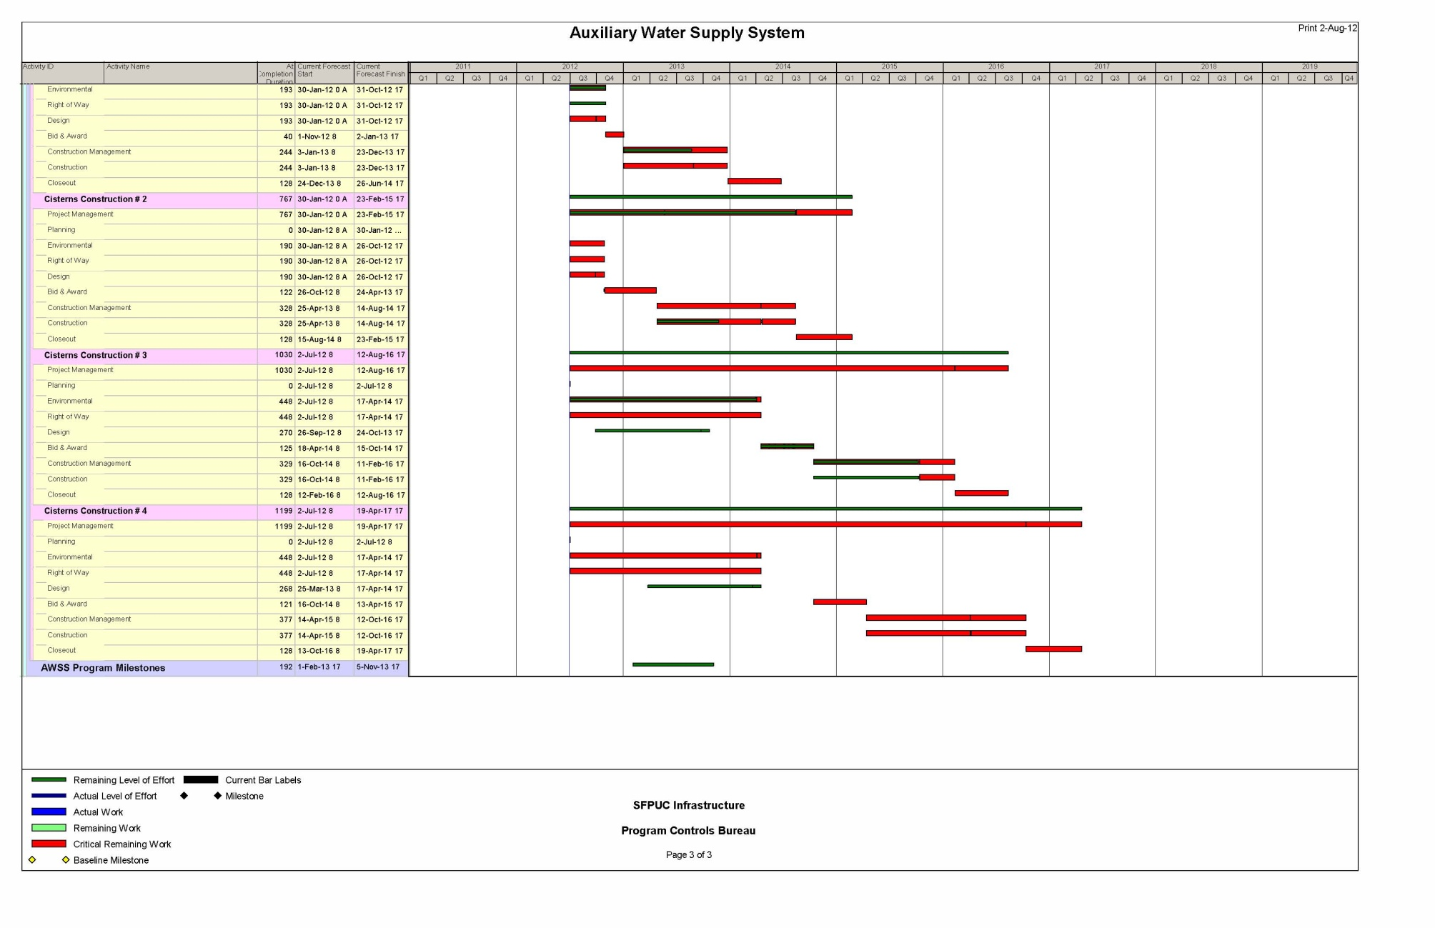



**City and County of San Francisco  
Office of the Controller**

**Public Oversight and Financial**

**Accountability Reviews and Cost of Issuance**

**Status:** The Department of Public Works (DPW) has prepared four quarterly reports thus far and has presented in front of the City’s Citizen General Obligation Bond Oversight Committee (CGOBOC) twice. A program web-site has been developed and these reports will be posted under program status. DPW is scheduled to present to the Committee on November 17.

**Budget:** Included in the $412,300,000 ESER Bond Program is a $6,900,000 budget for the public oversight and financial accountability reviews as well as the bond cost of issuance (COI). The budget is comprised as follows:

|  |  |
| --- | --- |
| Public Safety Building | $4,000,000 |
| Neighborhood Fire Stations | $1,100,000 |
| Auxiliary Water Supply System (AWSS) | $1,800,000 |
| **Sub-Total** | **$6,900,000** |

**Current Expenditures:** The expenditures increased by $5,719 from $1,115,665 to $1,121,384.

**Current Allocations:** The appropriation remained at $2,737,358.



# funding

The total appropriation from the General Obligation Bonds sale proceeds is $301,115,000 and $8,272,000 from the Fire Facility Bond Funds. Together the total appropriation authorization is $309,387,000.



# Attachment 1 – Contact Information

|  |  |  |  |  |
| --- | --- | --- | --- | --- |
| **Department of Public Works** | |  |  |  |
| **Bureau of Project Management** | |  |  |  |
| **30 Van Ness Avenue, Suite 4100** | |  |  |  |
| **San Francisco, CA 94102** | |  |  |  |
| **(415) 557-4700** |  |  |  |  |
|  |  |  |  |  |
| *Contact* | *Title* | *Telephone No.* | *Cell No.* | *E-mail* |
| Charles A. Higueras | Program Manager | (415) 557-4646 | (415) 307-7891 | [charles.higueras@sfdpw.org](mailto:charles.higueras@sfdpw.org) |
| Jim Buker | Senior Architect | (415) 557-4758 | (415) 225-9481 | [jim.buker@sfdpw.org](mailto:jim.buker@sfdpw.org) |
| Gabriella Judd Cirelli | Project Manager | (415) 557-4707 | (415) 279-4395 | [gabriella.cirelli@sfdpw.org](mailto:gabriella.cirelli@sfdpw.org) |
| Samuel Chui | Project Manager | (415) 558-4082 | (415) 272-8293 | [samuel.chui@sfdpw.org](mailto:samuel.chui@sfdpw.org) |
| Youcef Bouhamama | Project Manager | (415) 557-4798 |  | [youcef.bouhamama@sfdpw.org](mailto:youcef.bouhamama@sfdpw.org) |
| Viviana Soper | Project Mgr. Asst. | (415) 557-4647 |  | [viviana.soper@sfdpw.org](mailto:viviana.soper@sfdpw.org) |
| Andrew Christiansen | Project Mgr. Asst. | (415) 557-4639 |  | andrew.christiansen@sfdpw.org |
| Marisa Fernandez | Financial Analyst | (415) 557-4653 |  | [marisa.fernandez@sfdpw.org](mailto:marisa.fernandez@sfdpw.org) |
|  |  |  |  |  |
| **Public Utilities Commission** | |  |  |  |
| **525 Golden Gate Avenue, 9th Floor** | |  |  |  |
| **San Francisco, CA 94102** | |  |  |  |
|  |  |  |  |  |
| *Contact* | *Title* | *Telephone No.* | *Cell No.* | *E-mail* |
| David Myerson | Project Manager | (415) 934-5710 | (415) 500-5449 | [dmyerson@sfwater.org](mailto:dmyerson@sfwater.org) |
|  |  |  |  |  |